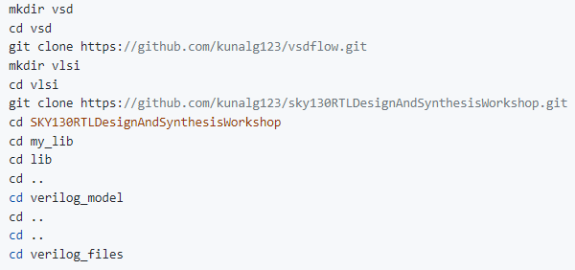**Labs using iverilog and gtkwave**

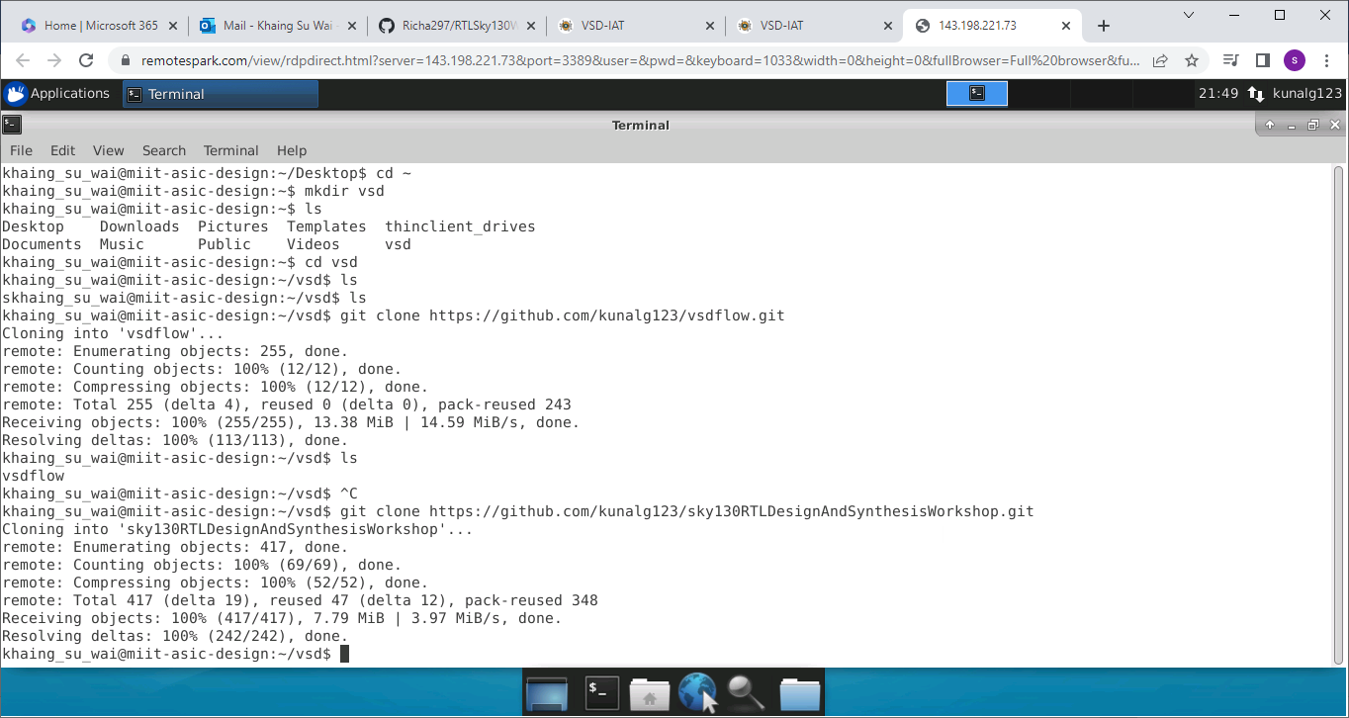Pic1

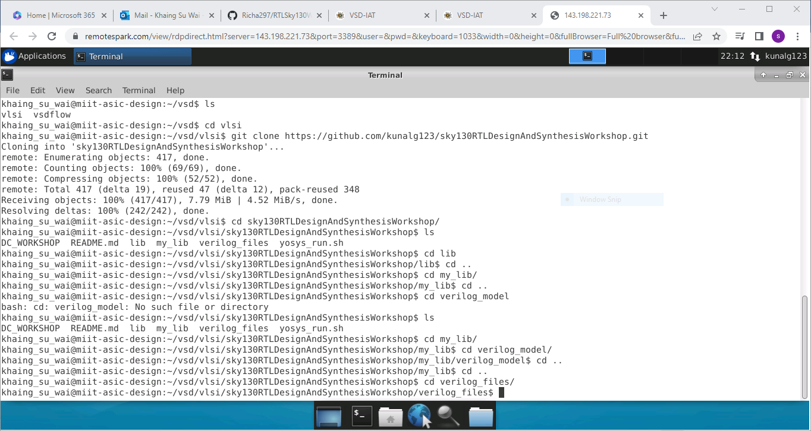Pic2

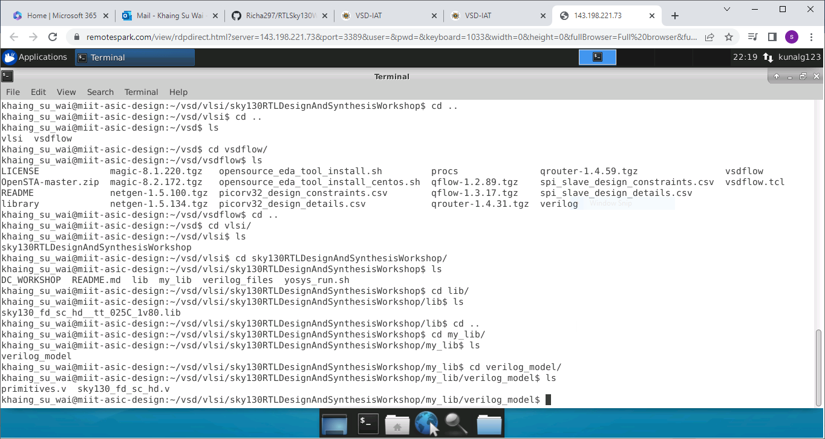Pic 3

Pic 4

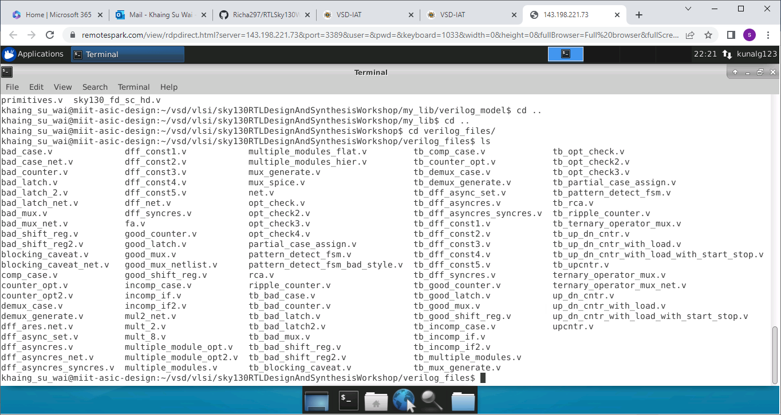

iverilog good_mux.v tb_good_mux.v

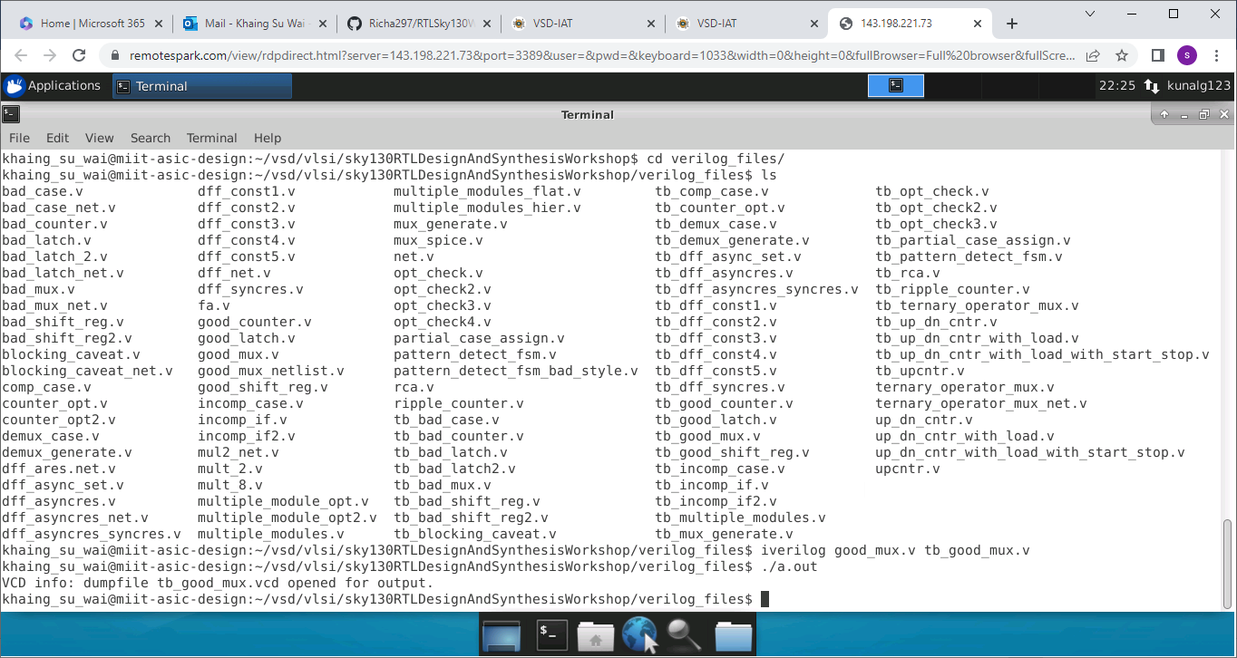Pic 5

gtkwave tb_good_mux.vcd

Pic 6

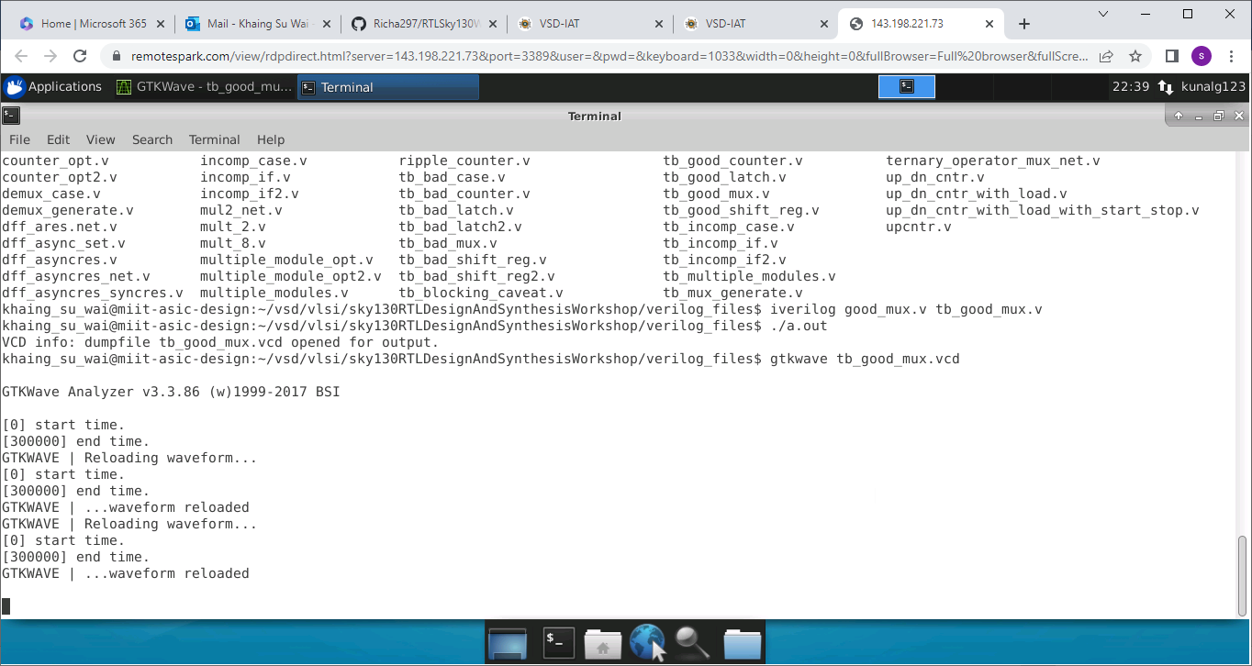

Pic 7

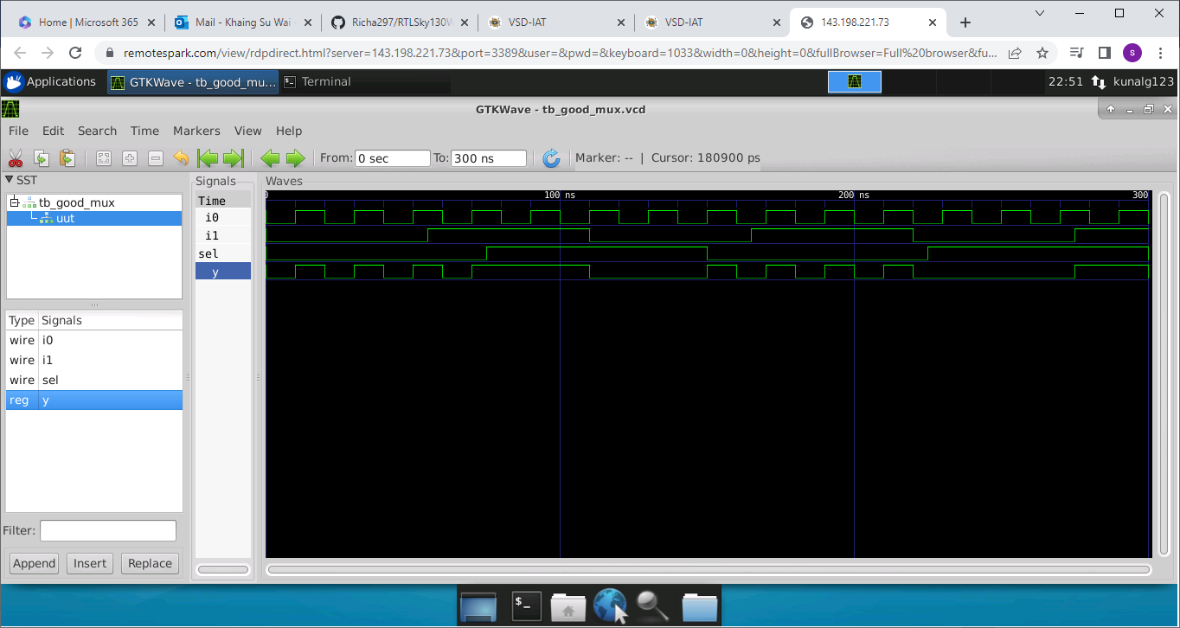

vim tb_good_mux.v -o good_mux.v

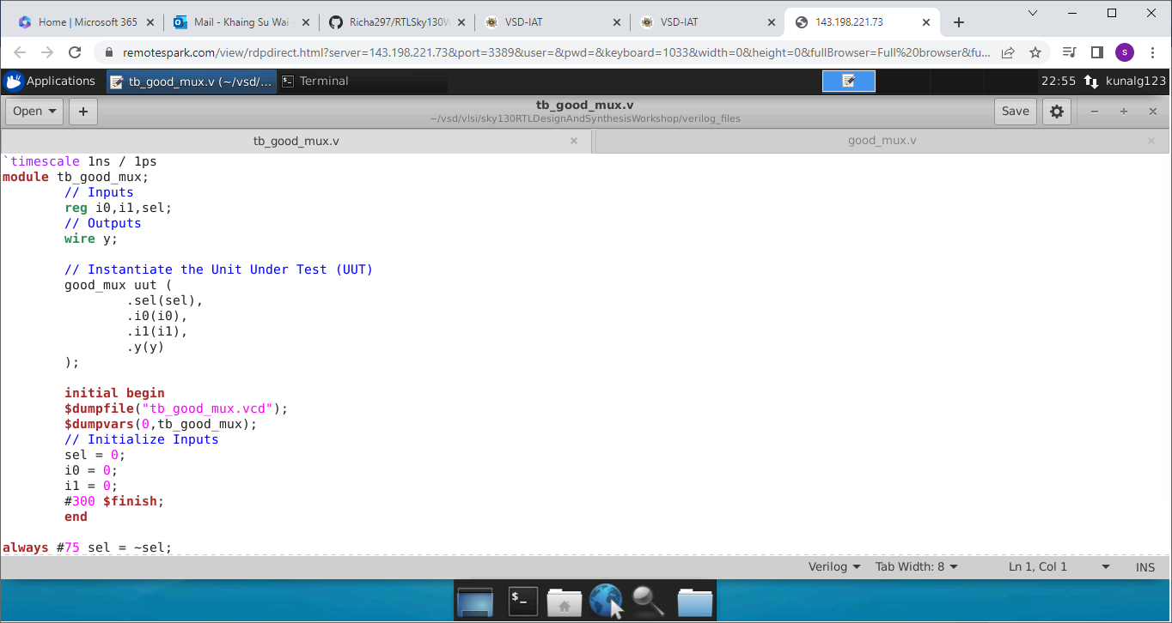Pic 8

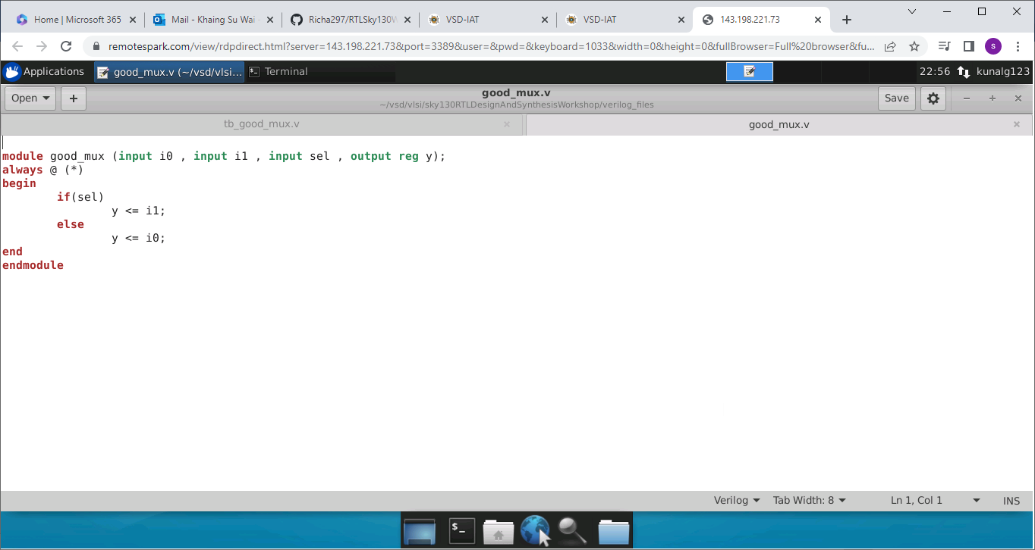Pic 9

**Labs using Yosys and Sky130 PDKs**

Pic 10

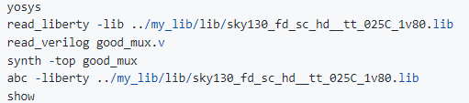After writing Commands to obtain a synthesized implementation of good_mux design

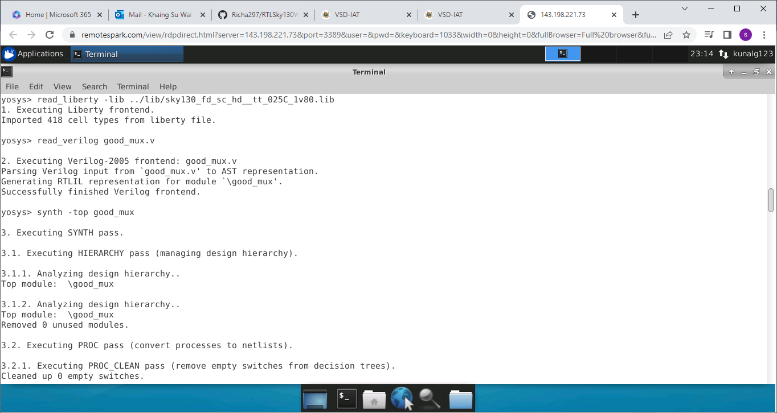

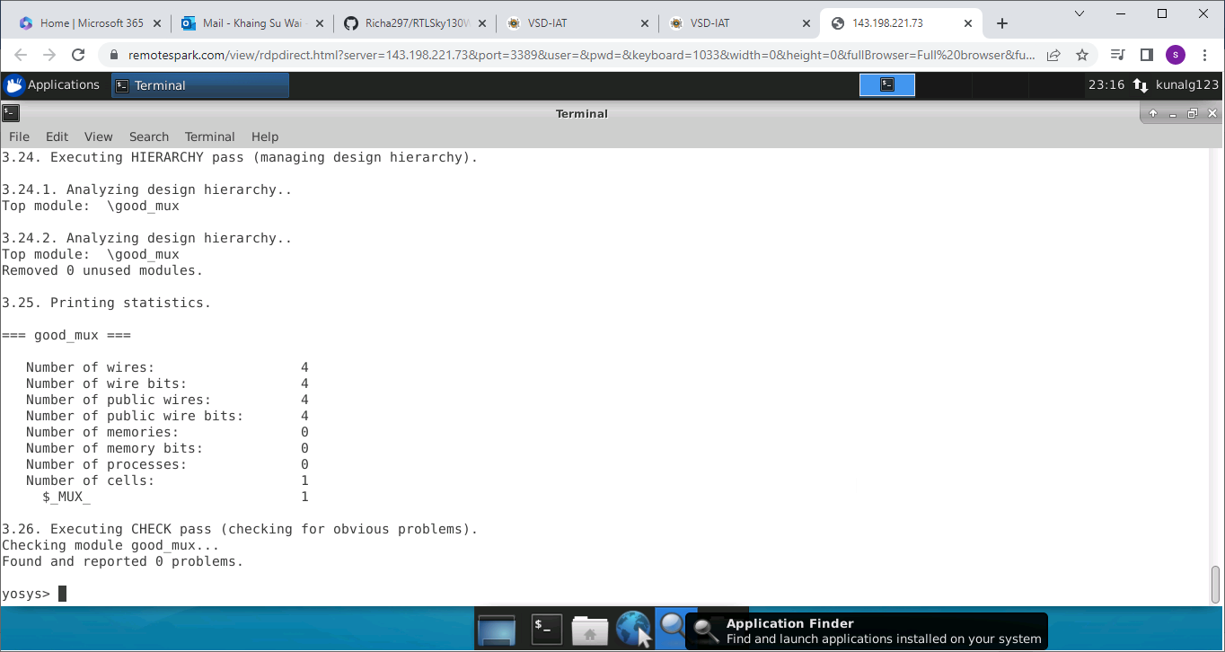Pic 11

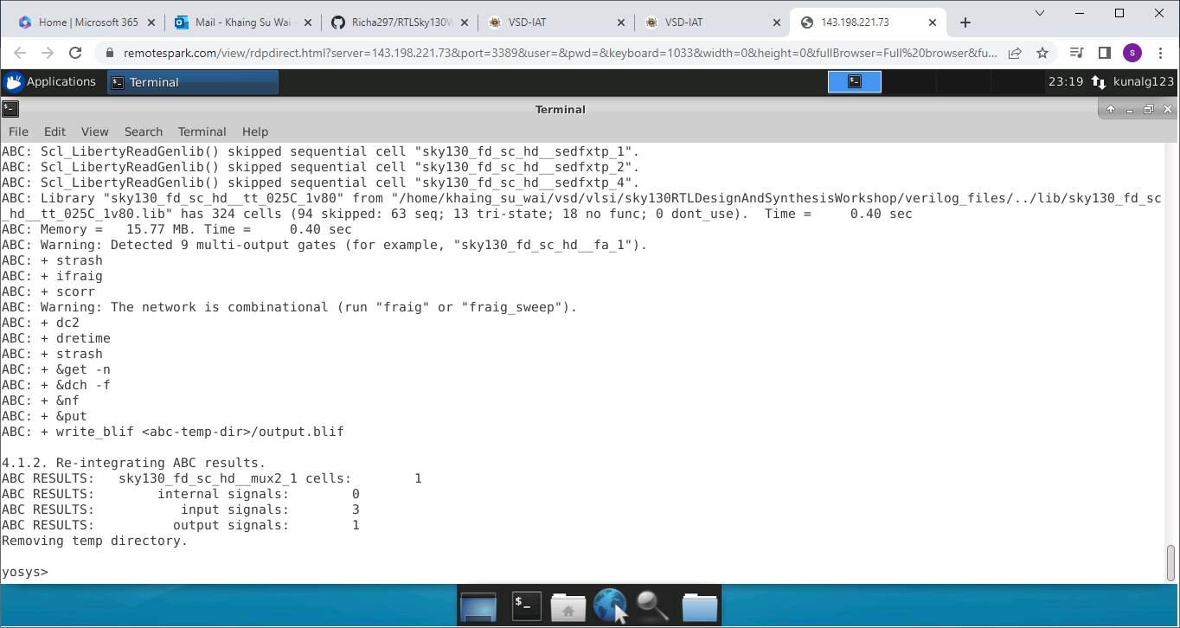Pic 12

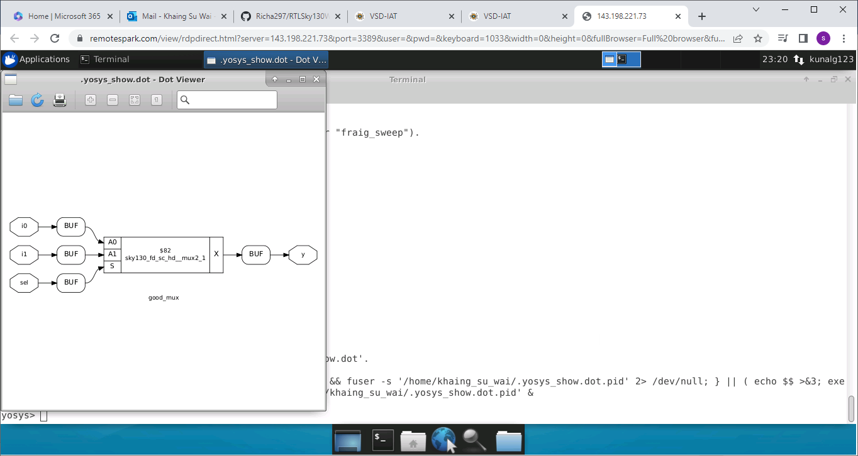Pic 13

Pic 14

write_verilog -noattr good_mux_netlist.v

!vim good mux_netlist.v

